

**How to Assemble the 4WD Car Chassis**

Table

1. Parts List 2

1.1 Connecting/Fixing Parts 2

1.2 Tool 4

2. Assemble and Install 5

2.1 Assembly steps 5

3. Make your suggestion and get support 18

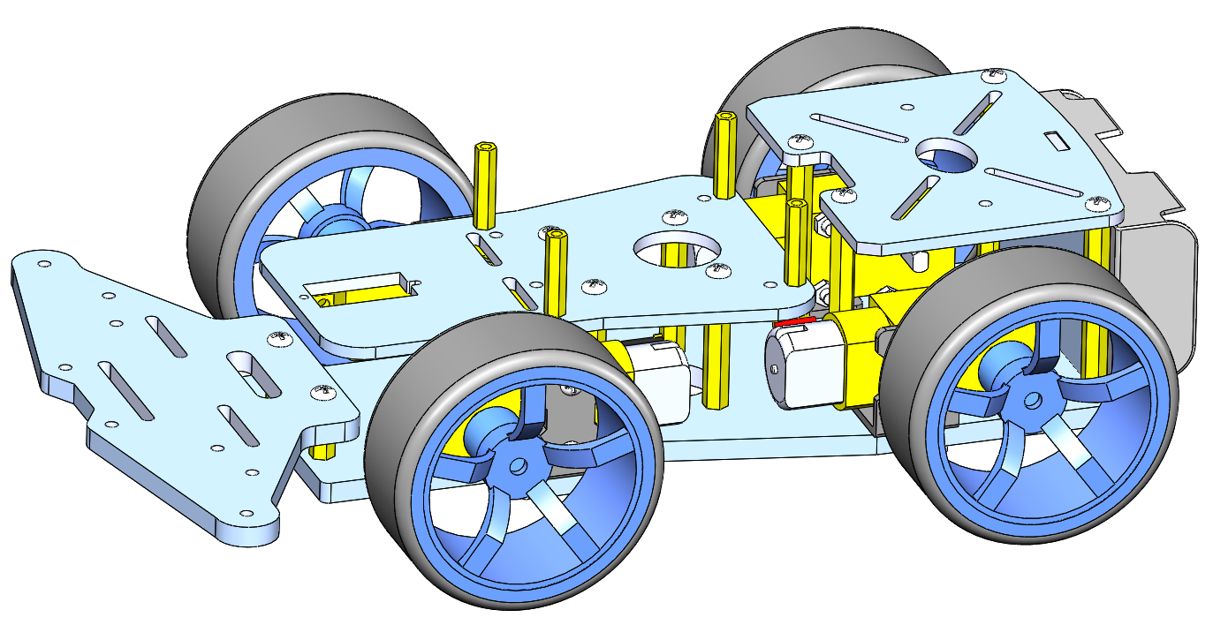

IT MAY BE MORE INTERESTING

WWW.COKOINO.COM

# Parts List

## 1.1 Connecting/Fixing Parts

|  |  |  |  |
| --- | --- | --- | --- |
| **Picture** | **Name** | **Description** | **Qty** |
|  | screw | M3*10MM round screw | 28 |
|  | screw | M3*25 countersunk head screw | 9 |
|  | screw | M3*8 countersunk head screw | 3 |
|  | screw | M3*8 round screw | 4 |
|  | nut | M3 nut | 10 |
|  | nut | M3 self-locking nuts | 9 |
|  | screw | M2.5*8 round screw | 9 |
|  | copper pillar | M2.5*20 double pass copper pillar | 4 |
|  | copper pillar | M3*10 double pass copper pillar | 2 |
|  | copper pillar | M3*30MM double pass copper pillar | 4 |
|  | copper pillar | M3*45 double pass copper pillar | 4 |
|  | battery case | 18650 battery case | 1 |
|  | motor | TT motor-dual axis reduction ratio 1:48 | 4 |
|  | bracket | TT motor metal bracket | 4 |
|  | wheel | TT motor wheel | 4 |
|  | acrylic structural parts | 4WD car base acrylic structural parts | 1 |

## 1.2 Tool

|  |  |  |  |
| --- | --- | --- | --- |
| **Picture** | **Name** | **Description** | **Qty** |
|  | wrench | M3 Simple Wrench | 1 |
|  | screwdriver | M3 Phillips screwdriver | 1 |

# Assemble and Install

## 2.1 Assembly steps

Note: 1. Before assembly, we need to use a screwdriver to peel off the protective paper of the acrylic structure;

|  |  |  |  |  |  |  |
| --- | --- | --- | --- | --- | --- | --- |
| Step | 1 | Assemble the bracket and the structure A | | | Tool | M3 Phillips screwdriver |
|  |
| List | Part Name | Quantity | Unit | Picture | | |
| structure A | 1 | PCS |  | | |
| bracket | 4 | PCS |  | | |
| M3 self-locking nut | 8 | PCS |  | | |
| M3*10 round head screw | 8 | PCS |  | | |
|  | Description | | | Demo | | |
| A | 1. Use M3*10 round head screws and M3 self-locking nuts to fix the bracket on the structural member A;  Pay attention to the installation direction of the bracket; | | |  | | |
| Step | 2 | Install the TT motor | | | Tool | M3 Phillips screwdriver |
|  |
| List | Part Name | Quantity | Unit | Picture | | |
| Step 1 part | 1 | PCS |  | | |
| TT motor | 4 | PCS |  | | |
| M3 nut | 8 | PCS |  | | |
| M3*25MM screw | 8 | PCS |  | | |
|  | Description | | | Demo | | |
| A | 1. Use M3*25 screws and M3 nuts to install the TT motor on the bracket of step 1 part (pay attention to the installation direction of the TT motor); | | |  | | |
| Step | 3 |  | Install Step 2 part with structure A | | Tool | M3 Phillips screwdriver |
|  |
| List | Part Name | Quantity | Unit | Picture | | |
| Step 2 part | 1 | PCS |  | | |
| M3*10 double pass copper column | 2 | PCS |  | | |
| structure B | 1 | PCS |  | | |
| M3*8 round screw | 4 | PCS |  | | |
|  | Description | | | Demo | | |
| A | 1. Use M3*8MM round head screws to fix the M3*10 double-pass copper column to structure A (pay attention to the installation direction of the copper column);  2. Use M3*8mm round head screws to fix structure B on the copper column; | | |  | | |
|  |  | | | | | |

|  |  |  |  |  |  |  |
| --- | --- | --- | --- | --- | --- | --- |
| Step | 4 | Install copper pillars | | | Tool | M3 Phillips screwdriver |
|  |
| List | Part Name | Quantity | Unit | Picture | | |
| Step 3 part | 1 | PCS |  | | |
| M3*45 copper pillar | 4 | PCS |  | | |
| M3*30 copper pillar | 4 | PCS |  | | |
| M3*10 round head screw | 8 | PCS |  | | |
|  | Description | | | Demo | | |
| A | 1. Use M3*10 round head screws to fix the M3*45 copper column and the M3*30 copper column on the structural member A in turn;  Pay attention to the installation direction of the copper column; | | |  | | |
| Step | 5 | Install the battery case | | | Tool | M3 Phillips screwdriver |
|  |
| List | Part Name | Quantity | Unit | Picture | | |
| Step 4 part | 1 | PCS |  | | |
| Structural C | 1 | PCS |  | | |
| Structural D | 1 | PCS |  | | |
| M3 nut | 2 | PCS |  | | |
| M3*8MM screw | 2 | PCS |  | | |
|  | M3*10 round screw | 4 | PCS |  | | |
| Battery case | 1 | PCS |  | | |
|  | Description | | | Demo | | |
| A | 1. Use M3*8 countersunk head screws to fix the 18650 battery case on the structure C (pay attention to the installation direction of the battery case);  2. Install the part completed in the previous step on the step 4 part;  3. Use M3*10 round head screws to fix the structural part D on the M3*45 copper column; (at the same time, pay attention to the combination of structural part C and structural part D) | | |  | | |
| Step | 6 | Assemble structural E and wheels | | | Tool | M3 Phillips screwdriver |
|  |
| List | Part Name | Quantity | Unit | Picture | | |
| Step 5 part | 1 | PCS |  | | |
| M2.5*20 double pass copper column | 4 | PCS |  | | |
| Structure E | 1 | PCS |  | | |
| M3*10 round head screw | 4 | PCS |  | | |
|  | M2.5*8 round head screw | 4 | PCS |  | | |
|  | Description | | | Demo | | |
| A | 1. Use M2.5*8MM round head screws to fix the M2.5*20 double-pass copper column to the structure E (pay attention to the installation direction of the copper column);  2. Mark the wires of the four motors so that you can know which wire corresponds to which wheel's motor in the future, and then organize the wires to pass through the middle circular hole of structural component E  9b7993270faccaa678f6ad7476510bb  3. Use M3*10mm round head screws to fix the part completed in the previous step on the step 5 part;    4. Install the wheels; | | |  | | |
| Congratulations, a 4WD car chassis has been installed!   Make your suggestion and get support THANK YOU for participating in this assemble document!  If you find errors, omissions or you have suggestions and/or questions about this document, please feel free to contact us: **[cokoino@outlook.com](mailto:cokoino@outlook.com)**  We will make every effort to make changes and correct errors as soon as feasibly possible and publish a revised version.  If you want to learn more about Arduino, Raspberry Pi, Smart Cars, Robotics and other interesting products in science and technology, please continue to visit our Amazon Store by search for "LK COKOINO" on Amazon. We will continue to launch fun, cost-effective, innovative and exciting products.  Thank you again for choosing Cokoino products. | | | | | | |